How to use the DKU JupyterLab GPU Container

- Login https://dkucc-ondemand-01.oit.duke.edu/ with your NetID.

- Select “Jupyter Lab - Teaching - Apptainer” under the Interactive Apps menu. As below

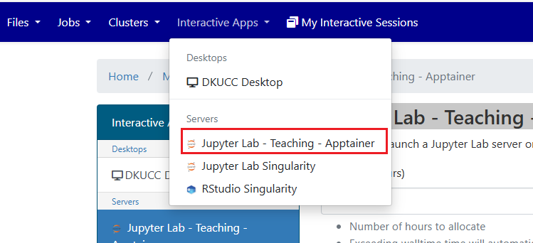

- Please refer to the following settings

Walltime (Hours) : Less than 24 hours
Email Address: Email address

Then click the Launch button and waiting minutes until the status change from Queued to Running, also you will receive an email notification.

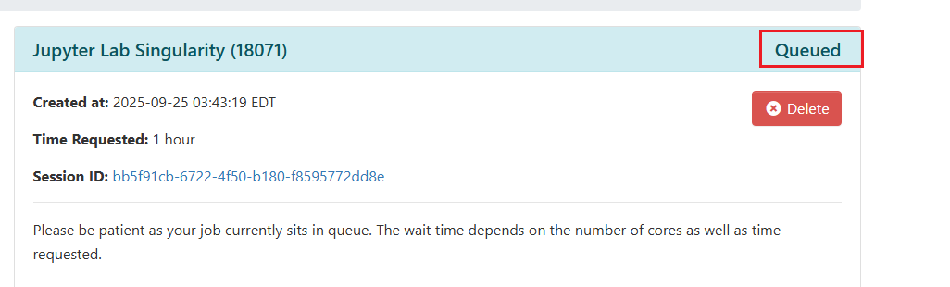

- Click the “Connect to Jupyter” button. A new browser window will open, and you can start using it immediately.

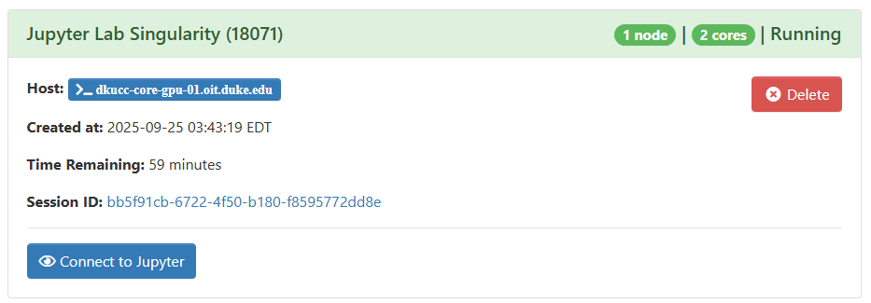

- Please click the “My Interactive Sessions” button, and you’ll see the Jupyter Lab – Teaching – Apptainer sessions you previously launched.

- Store your files under: /dkucc/group/courses/compsci304-2526-s3/<netid>
(Create your own folder first using the mkdir command.)
- File Storage Location
1. File Storage Location

You should store your files under the course directory :
/dkucc/group/courses/compsci304-2526-s3/<netid>

Data in other directories, such as /work and /dkucc/home, will be automatically deleted after 75 days. However, data in this course directory will only be removed manually after the course ends.

2. Accessing Course Directories via Jupyter

The Jupyter home directories are located at /dkucc/home/<netid>, while the course directory are located at /dkucc/group/courses/compsci304-2526-s3/<netid>

If you find it inconvenient to switch between these paths, you can create a symbolic link in your home directory so that the Jupyter file browser can directly access the course directory. For example, from a terminal in their home directory, you can run:

ln -s /dkucc/group/courses/compsci304-2526-s3 compsci304-2526-s3

